(1) Popularity contest.

I chose katz centralities as the measure of popularity. The rationale is that more degree a node has, and more connections it has with high-degree nodes, more popular the node is. So both eigenvector and katz centralities can be appropriate, but I prefer the latter since it is the generalization of the former and also overcome some computational issues that the former may have. The visualization is shown below. The size and color denote the level of centralities. As we can see, Grin, SN4, Topless, and Scabs are the most popular dolphins.

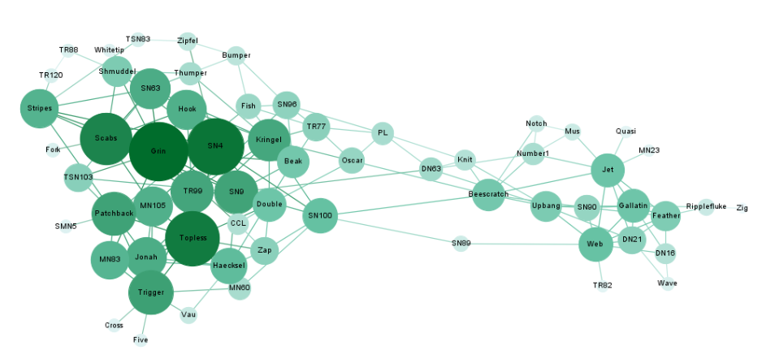

(2) Relay

I chose betweenness centralities as the measure of message replay because nodes with higher betweenenss centralities tend to stand on the shortest paths between other pairs of nodes. That is, they are more likely to pass message through the network. The visualization below shows that SN100 and Beescratch are the most important message relayers. 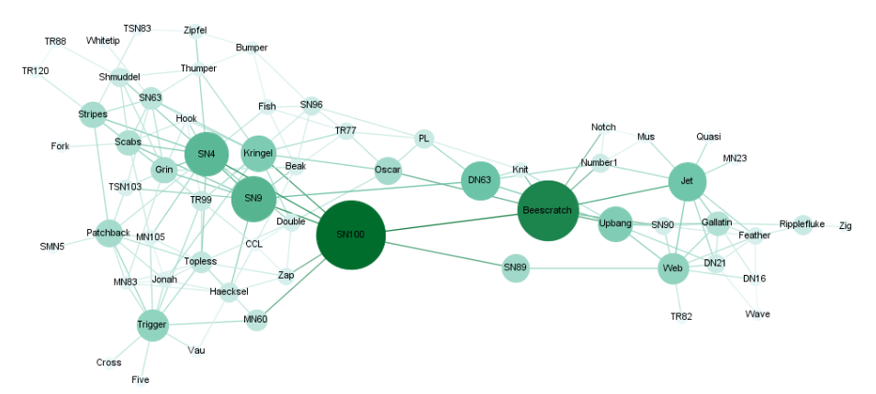

(3) Gossip

I chose closeness centralities as the measure of getting gossip because nodes with higher closeness centralities are advantage in reaching out all other nodes in the network. So it is easier for them to get all the best gossip from other nodes. The visualization below shows that SN100, SN4, SN9, Kringel, and Beescratch are the most important dolphins.

